Date/Time | Activity | Location/Where? | Subs/Cost
Thursday 14th September  7:30-9:30pm | Doubles Pool Tournament  & Music Quiz | 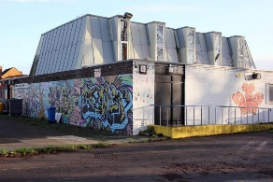  Searchlight | £4
Thursday 28th September  7:30-9:30pm | Bowling Trip | 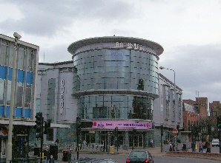  Kingston Odeon, The Rotunda | £10
Thursday 12th October  7:30-9:30pm | Film Night | Searchlight | £4
Thursday 26th October  7:30-9:30pm | Halloween Cooking: Pumpkin Pie & Telling Ghost Stories | Searchlight | £4
Thursday 9th November  7:30-9:30pm | Bonfire Night: Toasting Marshmallows and Stuffing the Guy | Searchlight | £4
Thursday 23rd November  7:30-9:30pm | Cooking: Cupcakes | Searchlight | £4
Thursday 14th December  7:00-9:00pm | Christmas meal & Secret Santa | The Foutain Pub, 120 Malden Road, KT3 6DD  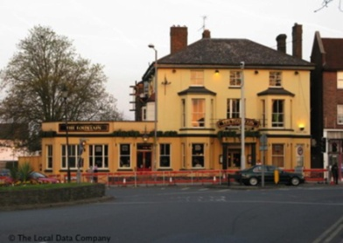 | £15

The address of Searchlight Community Centre is Kingston Road, New Malden KT3 3RX.
If you have any questions, please contact Charlotte Richardson (club leader) on 07508 079102 or Charlielikesmarmite@gmail.com

